FBL3N - FBL3N - Account Line Item Analysis

Functionality
You can display & change documents posted to a particular account provided that:
- This G/L accounts is managed with line item display
- The account master is not defined as a Reconciliation account.

This document covers G/L Account Line Item Display. This report allows you to:
- Display and change line items,
- Print a report or export it in MS Office document formats (Excel or Word).

Scenario
You want to check and print account line items.

Requirements
Defined GL Master record(s). Posted documents.

Menu Path | Accounting → Financial Accounting → General Ledger → Account → FBL3N - Display/Change Line Items
Transaction Code | FBL3N

1. Double click on FBL3N - Display/Change Line Items

G/L Account Line Item Display

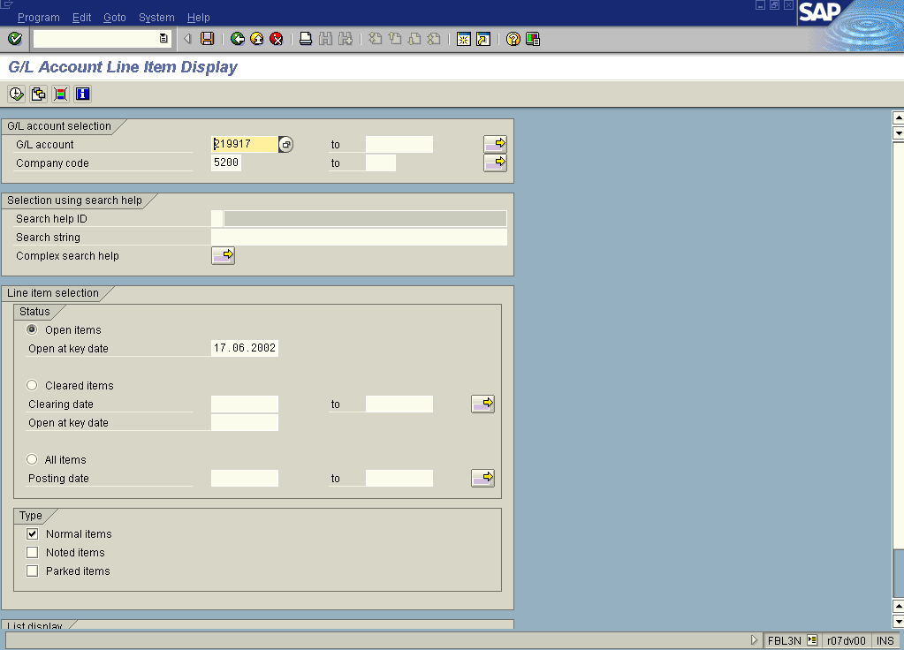

2. Update the following fields:

Field Name | Field Description | Values
G/L account | Code identifying a General Ledger account | Example: 219917
Company code | Code identifying a separate legal entity for which a separate set of accounts is maintained for external reporting purposes | Example: 1200

 This screen requires additional explanation. You can display the following types line items:
- only open items (at particular date),
- only cleared items,
- items posted at a key date or within a specified period of time.

You can also ask the system to display noted items or parked documents, and you can also select the screen layout you prefer – just click on the relevant radio button.

The SAP system during operation clearing always creates and stores a special clearing document (including a clearing date). That’s why it is possible to display open line items within a specified period of time even if they’re cleared at present.
3. To confirm your entries, click Enter .
4. Click Execute to display a report, according to entered criteria:

G/L Account Line Item Display

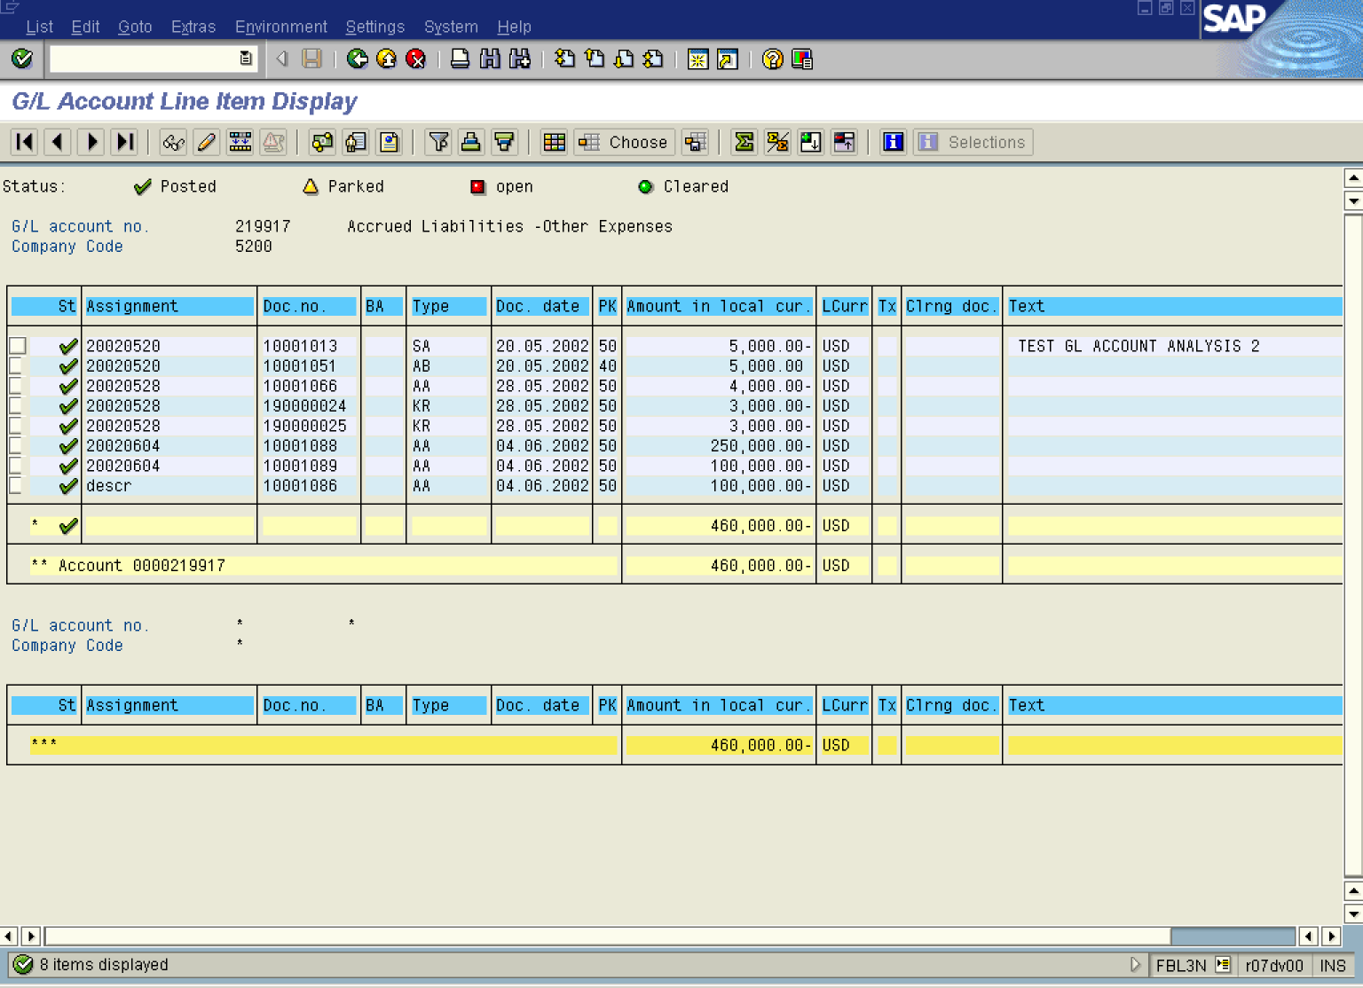

Tip: You can export your report to MS Excel or MS Word. Select from menu path List -> Export -> Spreadsheet or Local file. The system will automatically open a requested MS Office application or create a file in required format.

5. You can display document details you want to check. Simply double-click on the document number (e.g. 10001013):

Display Document: Line Item 002

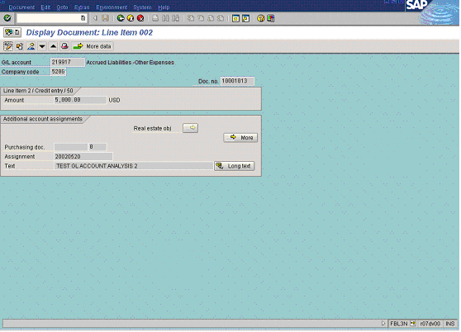

6. Some fields in this document can be changed. To do so, click Display - Change Button . Fields that can be changed are highlighted in red:

Change Document: Line Item 002

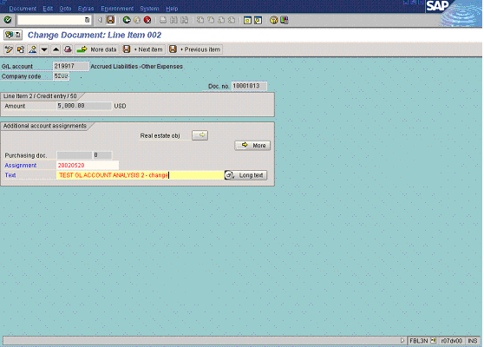

7. To change line item description update the following field:

Field Name | Description | Values
Text | Additional Line item description | Example: TEST GL ACCOUNT ANALYSIS 2 - change

8. To save your changes, Click Save Button..

9. The message bar displays “Changes have been saved”.

